OFA Eye Clinic

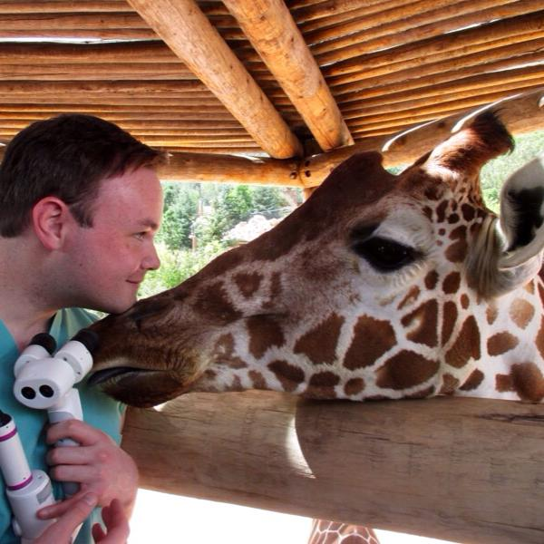
May 11, 2019
9am-2pm

At Gamekeepers Retrievers
Frazeysburg, OH

Cost: $35 per dog
Gonioscopy offered for $90

All breeds are welcome!

Contact Adam King at askingdvm@gmail.com or Maria White at gamekprs@gmail.com
for more information.
Adam King, DVM, MS, DACVO, is a longtime Havanese breeder and dog show participant both as an owner/handler and judge. He is the chair the Genetics Committee for the American College of Veterinary Ophthalmologists and sits on the Havanese Club of America Health Committee and Judges Education Committee. Dr. King also offers regular education opportunities for AKC breeders who wish to know more about canine eye-health challenges. For regular and on-going eye care, visit Dr. King at MedVet Chicago. More info at: https://www.medvetforpets.com/location/medvet-chicago/

